- S03-GenerateAPITestcasesFromSwaggerCode
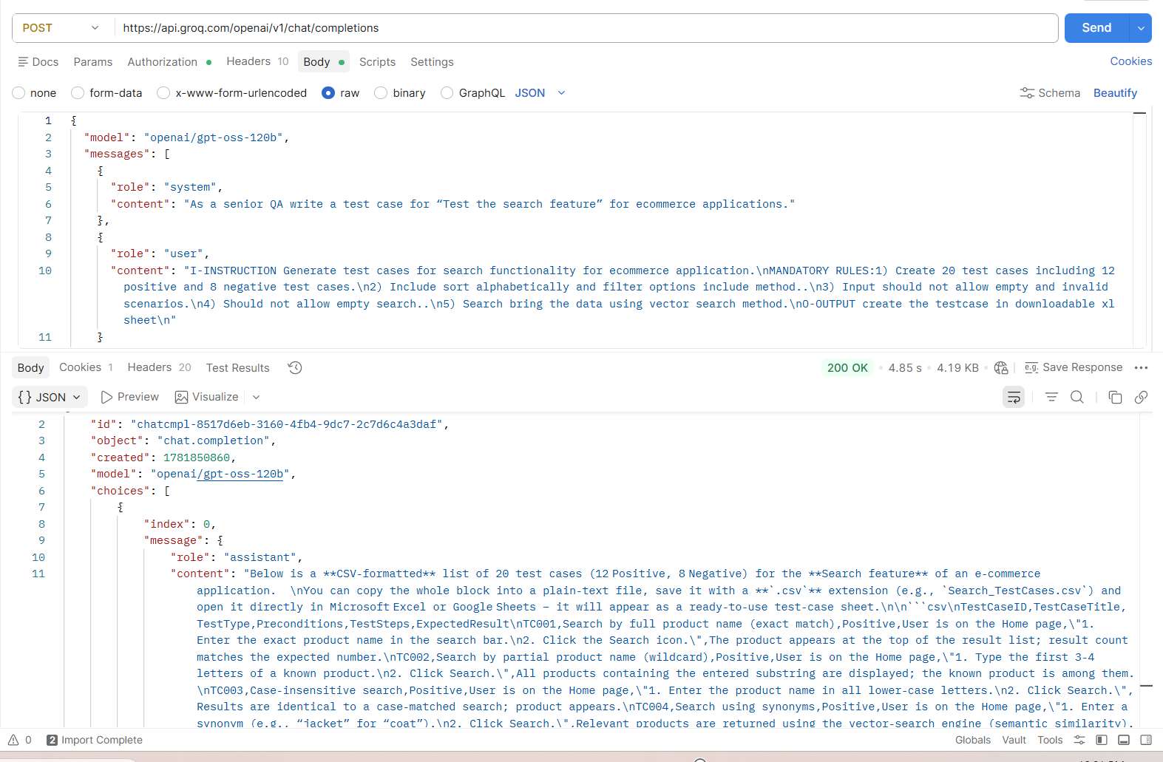
2. S02- MultiLingual
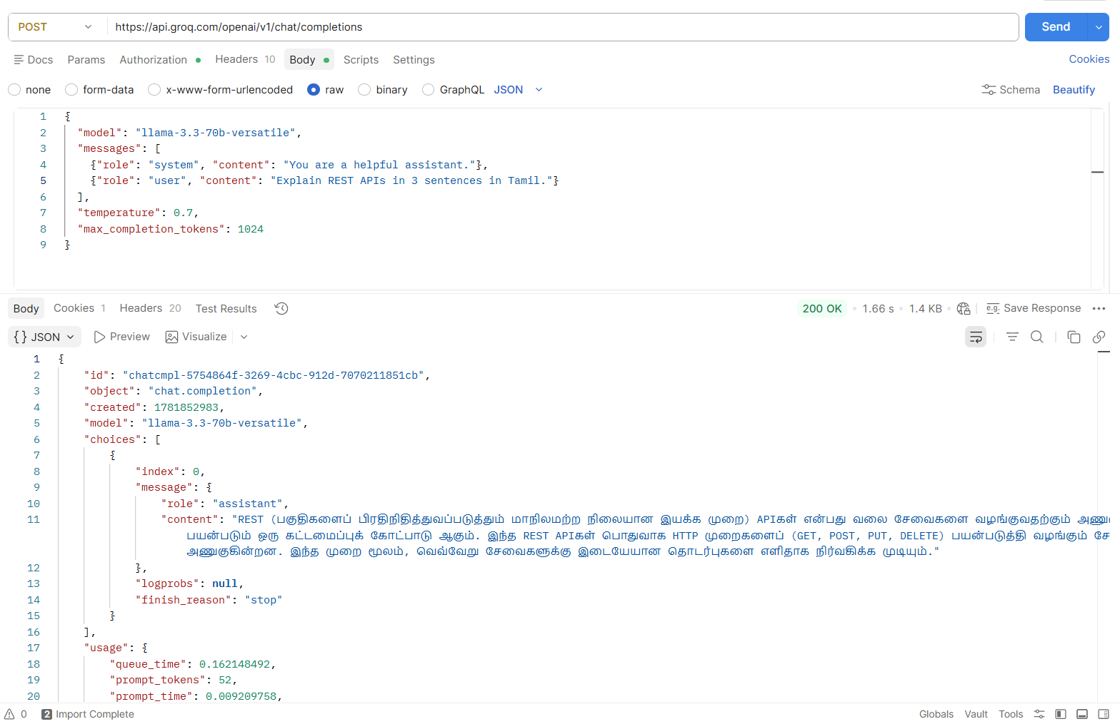
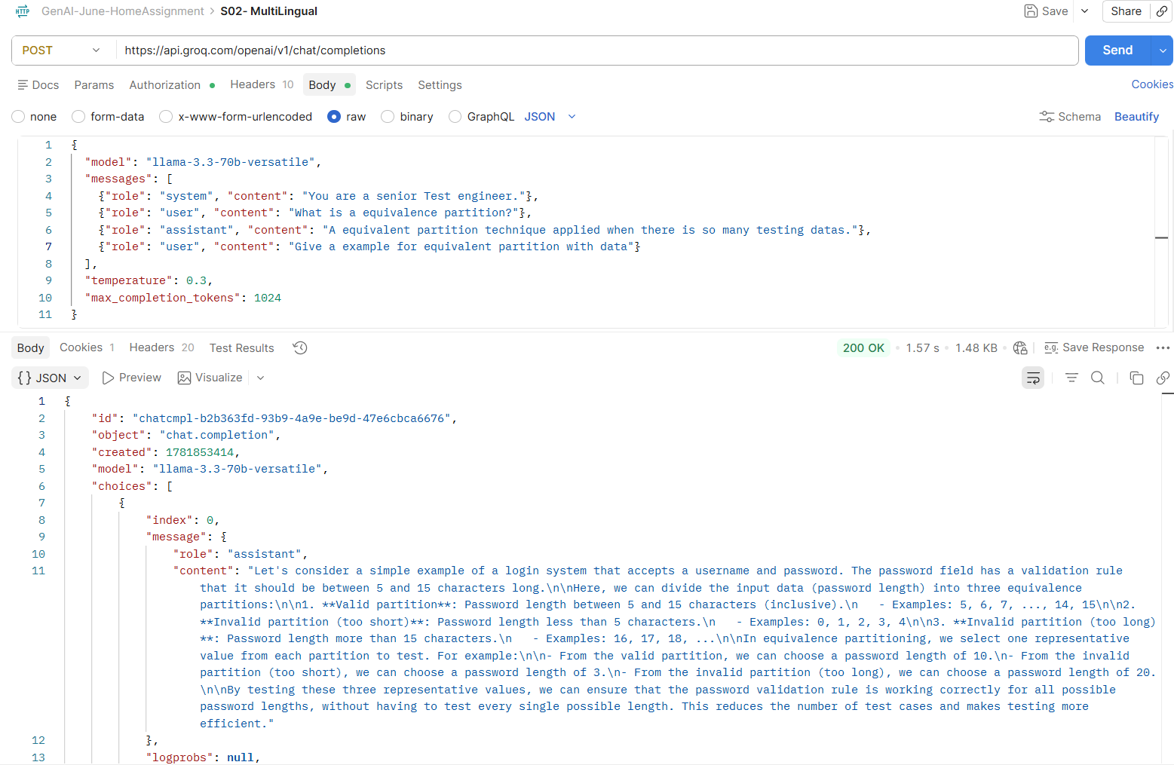

3. S01-Text to Audio
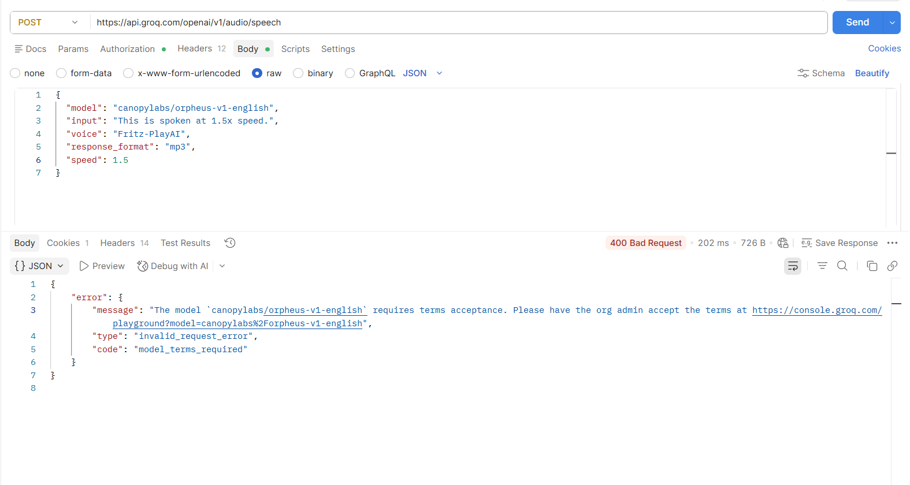
Some reason my organization blocks this model, I tried with example one as well.

